Athlete Instructions: RecPlex Indoor/Outdoor Triathlon

Format
- 400 yard pool swim in the Waterpark lanes; one lap = 50 yards, race distance is 8 laps.
- 4 mile pedal on ICG spin bikes, which will be in LakeView Studio.
- 2.3 mile clockwise run around Lake Andrea on the path.
- Note this is a distance based event, not timed like in February, & November Indoor Triathlons.
- Transition time will count in this race, including time to set up the bike. Bikes may not be“reserved” before you start.
- You must wear your race number on the front and clearly visible by the finish line volunteers when you cross the finish line. Failure to do so may result in an incorrect race time, with no appeal. Numbers can be picked up at registration, along with safety pins.
- The decision whether we can race outside will be made by at 6:45 on race morning. We will be outside unless the weather is dangerously bad – blizzard, lightning storm, etc. (FYI: in the many years of doing Indoor/Outdoor Triathlons, we’ve never cancelled the outside run.)

What you will want to bring
- Standard tri clothing. Shirt/singlet is required for both men and women – no bare torsos on the bike or run. Remember to be prepared to run outside, which could mean jacket, hat, gloves, sunscreen, sunglasses, etc. You will also need to wear a race number. Safety pins will be provided or you may bring a race belt.
- Lock for lockers if you choose to use the locker room during or after the race.
- Swim caps are optional and are not provided.
- Towels – the RecPlex does not provide towels. Please bring a towel to dry off after the swim (T1) and if you want to take a shower afterward. We also recommend you bring a small towel for the bike if you sweat profusely.
- Bike Shoes are optional, and must be SPD compatible. The spin bikes have dual pedals, with a standard “cage” on one side and SPD cleat on the other. Remember though that transition time does count when deciding whether to bring bike and running shoes.
-Important: if you wear bike shoes, they cannot be left by the spin bikes during your run. They must be placed with your other gear in transition.
-Per USA Triathlon rules (Section 7.2 Placement of Equipment), if a participant leaves equipment – e.g., bike shoes, towels – outside of the transition setup, they will be assessed a time penalty. First offense: 2 minutes. Second offense: 4 minutes. Third penalty: disqualification.
- All waves start on time. It is your responsibility to be in position and ready to go at your start time. You will be able to warm up in the pool if desired, but all athletes must be at the wall one minute before your wave begins.
- Please confirm your wave start time a day or two before the race to make sure you have the right time.
- If you miss your wave start, you will not be allowed to begin the race. No exceptions.
Race Day
- Check-in starts at 7:00am. Please note the RecPlex does not open until 6:55am.
- Participants should check-in 20-30 minutes before their wave starts. Check-in will be in Starfish, on the first floor (not upstairs in the Fitness Center).
- The first wave starts at 7:30am and every 25 minutes thereafter.
- Transition will be in Starfish Room.
- Do not leave any valuables in the transition area. The RecPlex is not responsible for lost or stolen items – please lock up valuables in the locker rooms.
- You have the option of transitioning in the locker rooms (though remember this will count as race time), which can be accessed through the Water Park. Please bring your own lock and towel. Note: do not run through the Water Park. Unsafe conduct and failure to follow lifeguard instructions will result in disqualification.

Swim
- 8 laps, two swimmers per lane, in the four lanes of the Waterpark. You will have a maximum of
  - 20 minutes to swim the 400 yards. Anyone still in the pool at their 20 minute mark must exit the pool and will receive a 5 minute time penalty.
- Choose right or left side and swim straight down and back – not a circle. Make sure your scorer knows your full name and whether you are left or right side.
- Athletes are responsible for counting their own laps and exiting the water at the correct distance. Confirm your distance with the scorer before you leave the pool.
-Lap = down and back, length = just down, or just back
-Think about a NASCAR race: when you do a lap, you finish where you started
- Swim caps are optional and are not provided.
- You may use any stroke; flip turns are allowed (but please try not to splash the scorers!)

Bike
- Volunteers will direct you to an open bike. After pedaling for 4 miles, notify a volunteer and do not get off the bike until they confirm the distance. We strongly recommend you bring a water bottle for the bike.
- Bike computer instructions – read carefully!!
a. We are using ICG Indoor Cycling bikes. Since these may be new to you, carefully follow the instructions of the scorers.
b. DO NOT PRESS ANY BUTTONS ON THE BIKE COMPUTER UNTIL INSTRUCTED TO DO SO, AND
ONLY PRESS THE BUTTONS ONCE. Repeated pressing buttons may erase your results with no chance of recovery.
c. Use the transition time to adjust the bike as needed.
d. When instructed to do so, start pedaling and press arrow to get to QUICK START:

QUICK START should be highlighted.
e. When instructed to start Press ✓ to select.

Distance should start recording. See photo below.
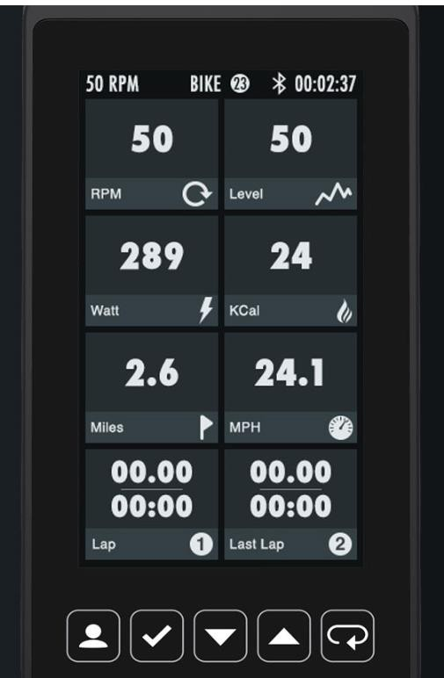

f. Bike distance is determined by Power. This is a combination of how hard you press the pedals, the resistance, and your cadence. Simply spinning the pedals as fast as you can will not give you a good result.

-At 4 miles raise your hand and notify the scorer so they can record your time, but stay on the bike until the scorer has confirmed your distance.

- You will have a maximum of 40 minutes for both the swim and the bike. Anyone still on the bike at 40 minutes after their wave start must begin the run, and will receive a 5 minute time penalty.
-For example, if your wave starts at 7:30:
- You must finish the 400 yard swim no later than 7:50 to avoid penalty
- You must finish the 5 mile spin bike no later than 8:10 to avoid penalty
-These rules are in place to prevent excessively slow participants from interfering with those in later waves.

Run
- Exit the Lakeview Studio and stay on the cement path to the lakefront path. Turn left, and follow the path clockwise around the lake.
-Clockwise means you will start running towards the flagpoles and Highway 165, and will finish by running back to the path by the Lakeview Studio.
- Finish line will be near path to Lakeview and will be manned by a volunteer to record your time.
- Note that the path is not closed for this event, so you must watch out for walkers, bikes, other runners, etc. Common running courtesy is expected. Aggressive behavior toward other users of the path will result in disqualification without appeal.

Post-Race
- When you have finished the race, please re-enter the Lakeview Studio by the same door where you exited for the run. Watch out for athletes exiting who are still racing!
- T-shirts, and refreshments will be available.
- Awards will be presented after all participants have finished and results are final.
-Results will be by overall race time. The recorded times will be wave start and athlete finish.
-Interim results may be posted during the race but are not official until all athletes have finished.
-Per USAT rules section 10.5, any protests or corrections must be discussed with the race director within 60 minutes of the person filing the protest finishing the race.
-Official results will be posted at on the RecPlex web site by Sunday evening.
-If you are not present for awards, they may be picked up later at the RecPlex Fitness Desk.

- Note on Parking: Parking in the RecPlex parking lot-controlled access for members only. Non- member parking is also available on the street and in the softball field parking lot as well as the Park and Ride parking lot across from our member’s parking lot.

Questions: contact kwhitman@pleasantprairiewi.gov

Have Fun, but Be Safe!

